About Section:
RM Geotex Limited, a subsidiary of Mamun Group, is a leading manufacturer specializing in high-quality Non-Woven Geotextiles, Geobags, and Geotubes in a variety of specifications and dimensions. The company's products have earned a distinguished reputation for their superior performance and reliability in numerous civil engineering applications. These include river and coastal engineering, erosion control, bank protection works, offshore protection using geotubes, as well as embankment construction, reinforced embankments and slopes, and retaining and protective structures.

To ensure optimal product performance and client satisfaction, RM Geotex Limited also offers comprehensive product marketing services that encompass technical design assistance, product selection guidance, and support for installation and monitoring.

In addition to its manufacturing capabilities, RM Geotex Limited provides specialized services in Geotechnical and Environmental Engineering. The geotechnical engineering services cover the entire project lifecycle—from site investigation, design, and technical proposals, to project execution, instrumentation, and performance monitoring. Key areas of expertise include ground improvement techniques, reinforced and anchored earth wall systems, and various other geosynthetic applications, offering clients an end-to-end solution—from problem identification to detailed design and successful implementation.

Furthermore, the company extends its engineering expertise to environmental engineering, with a focus on waste containment, cut-off and seepage sealing systems, and landfill engineering solutions, addressing critical environmental challenges with sustainable and effective practices.

Specialized geotechnical engineering solutions Section:
RM Geotex Limited is among the select few organizations in Bangladesh with extensive expertise in the field of geotechnical engineering. The company is recognized for delivering specialized and comprehensive geotechnical engineering solutions tailored to meet diverse infrastructural needs. Through a strategic collaboration between RM Geotex Limited and RM Engineering Ltd., clients are offered an integrated, one-stop solution encompassing engineering design, high-quality material supply, and end-to-end project execution.
The scope of services provided includes, but is not limited to:
- Soft Soil Stabilization: Implementation of advanced techniques to improve the load-bearing capacity and overall stability of weak and compressible soils.
- Embankment Construction: Design and execution of embankments for roadways, railways, and flood control systems, ensuring structural integrity and longevity.
- Vertical Walls with Geosynthetics: Construction of reinforced vertical retaining walls using geosynthetic materials to provide efficient and sustainable solutions for space-constrained areas.
- Supply and Installation of Prefabricated Vertical Drains (PVDs): Use of PVDs to accelerate soil consolidation and improve ground conditions in soft soil areas.
- Riverbank and Coastal Erosion Protection: Design and implementation of measures to prevent erosion and safeguard riverbanks and coastal areas from environmental degradation.
- Slope Protection: Application of erosion control methods and structural reinforcement to maintain slope stability and prevent landslides.
In addition to offering high-performance non-woven geotextiles is the exclusive distributor in Bangladesh of Huesker geosynthetic products. These include high-strength and reinforced geotextiles, woven geotubes, geogrids, geomembranes, and geosynthetic clay liners, all of which are essential for demanding geotechnical and environmental engineering applications.

Application Sections:
The unique properties of needle-punched non-woven geotextile fabrics—specifically their ability to effectively retain soil particles while permitting the free flow of water—make them highly suitable for filtration and separation applications. The manufacturing process begins with the cutting and opening of polypropylene filaments, which are then formed into a web-like structure. This web is subjected to a mechanical bonding process wherein thousands of barbed needles repeatedly penetrate the material, orienting and interlocking the fibers to create a cohesive and durable fabric.
RM Geo-textile Ltd. produces high-performance needle-punched non-woven geotextiles that demonstrate exceptional filtration efficiency and hydraulic conductivity. These geotextiles are among the most versatile in the industry, suitable for a wide range of civil engineering and environmental applications. The fabrics are available in various weights to meet diverse project requirements, with the heavier grades offering enhanced tensile strength and durability.
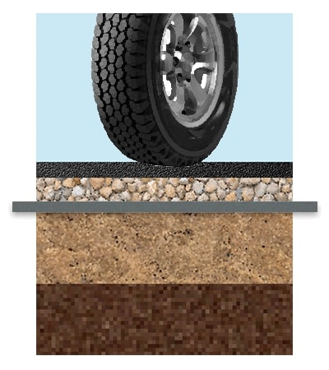
Road Construction:
In roadway construction, needle-punched non-woven geotextile fabric functions as both a separation and filtration layer. It effectively prevents the intermixing of subgrade soil and aggregate layers, thereby inhibiting the upward migration of fine particles and small gravel. This enhances the structural integrity and longevity of the roadway by maintaining the designed layer composition and promoting proper drainage.
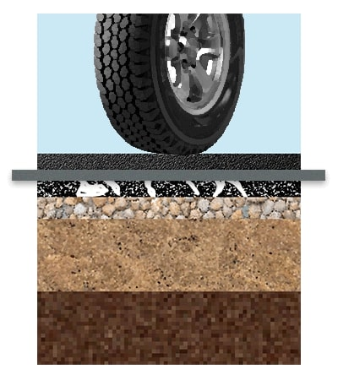
Road Maintenance:
In road maintenance applications, needle-punched non-woven geotextile fabric serves as an effective pavement interlayer between existing and newly applied asphalt layers. This interlayer function significantly reduces the occurrence of reflective cracking by absorbing stresses and distributing them more evenly across the pavement structure. As a result, it enhances the durability and lifespan of the rehabilitated roadway.

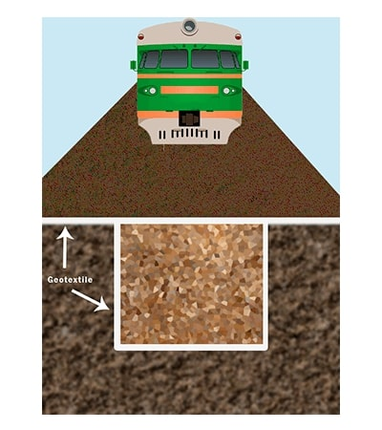
Railway Embankment:
In railway embankment construction, needle-punched non-woven geotextile serves a dual function by providing both tensile reinforcement and filtration. By allowing water to pass through while preventing soil particle migration, it enhances drainage and soil stability. Additionally, the tensile properties of the fabric contribute to improved load distribution and increased structural capacity of the embankment, thereby supporting long-term performance and resilience of the railway infrastructure.
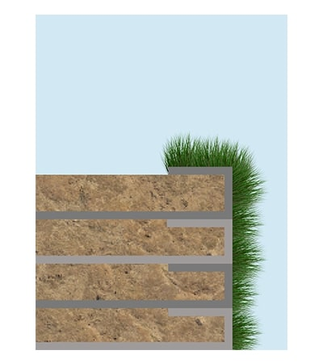
Earth Retaining Structures:
Needle-punched non-woven geotextile is used to stabilize earth walls through reinforced wrap-around techniques. By confining and reinforcing soil layers, the fabric enhances the overall structural integrity and stability of the retaining wall system. Its ability to resist tensile forces and maintain soil cohesion makes it an effective solution for constructing durable and secure earth retaining structures in both temporary and permanent applications.

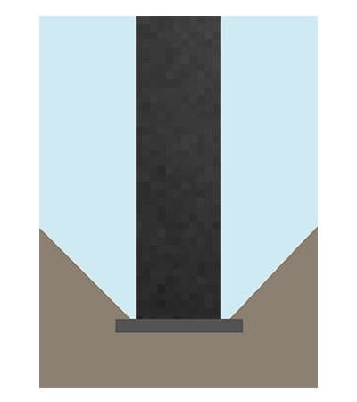

Foundation Stabilization:
Needle-punched non-woven geotextile plays a critical role in stabilizing the base foundation of construction projects. By providing a stable separation layer between subgrade soil and structural fill materials, it enhances load distribution and prevents contamination of aggregate layers. In many cases, it can effectively replace traditional blinding layers, offering improved performance in terms of filtration, separation, and ease of installation. This contributes to a more efficient construction process and a longer-lasting foundation structure.
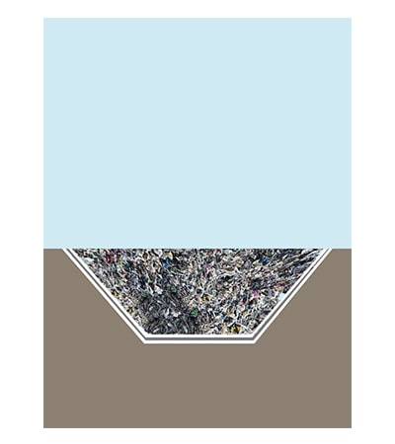
Landfill Applications:
In landfill engineering, needle-punched non-woven geotextile serves as a crucial protective layer. It acts as a barrier that shields the underlying soil from contamination by leachate and simultaneously protects the geomembrane liner from mechanical damage caused by sharp objects or irregularities in the subgrade. By providing cushioning and filtration functions, the fabric enhances the integrity and longevity of the landfill containment system, ensuring compliance with environmental protection standards.

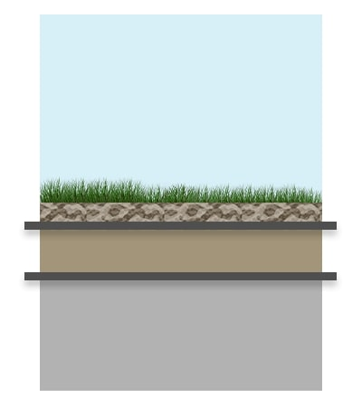
Green Roof and Garden Applications:
Geotextile grow bags made from needle-punched non-woven fabric are ideally suited for use in rooftop gardens. The fabric functions as a separation and drainage layer, effectively filtering excess water while preventing soil migration. This promotes healthy root development, prevents waterlogging, and maintains structural separation between the soil medium and the drainage layer. Its durability and permeability make it an optimal choice for sustainable green roof systems and container gardening applications.

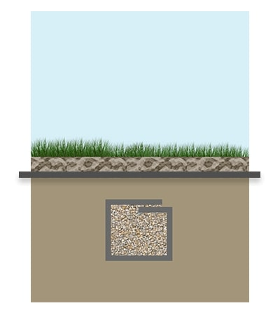

Drainage Systems:
When used to wrap around drainage trenches, needle-punched non-woven geotextile fabric serves as an effective filtration barrier. It prevents fine soil particles from entering and clogging the drainage system, while still allowing water to pass through freely. This ensures long-term functionality and efficiency of subsurface drainage by maintaining consistent water flow and preventing sediment accumulation. The fabric’s permeability and durability make it an essential component in trench drain construction and other subsurface water management applications.

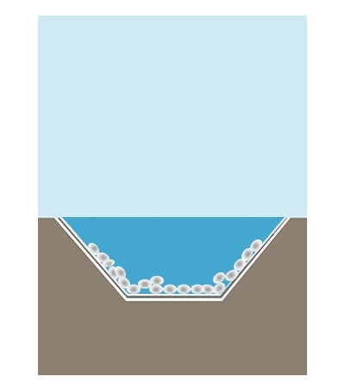
Artificial Lakes and Reservoirs:
Non-woven geotextile fabric is extensively utilized in the construction and maintenance of artificial lakes and reservoirs to prevent leakage and control erosion. Acting as a protective layer, the fabric safeguards geomembranes or clay liners from punctures and mechanical damage caused by soil movement or debris. Additionally, it helps stabilize the surrounding soil, reducing erosion along the banks and ensuring the structural integrity and longevity of the water containment system.
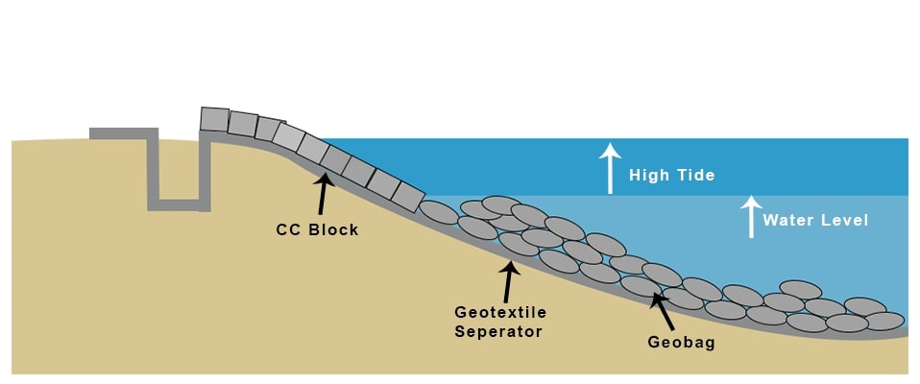

Riverbank and Shoreline Protection:
Erosion control along riverbanks and shorelines is effectively achieved through the use of geo-bags and cement concrete (CC) blocks. Geo-bags, filled with suitable materials, act as flexible, permeable barriers that absorb and dissipate the energy of flowing water, thereby reducing soil erosion. Complementing this, CC blocks provide a durable and stable structural reinforcement to protect vulnerable areas from further degradation. Together, these methods offer a comprehensive solution for maintaining the integrity of riverbanks and shorelines in both natural and engineered environments.

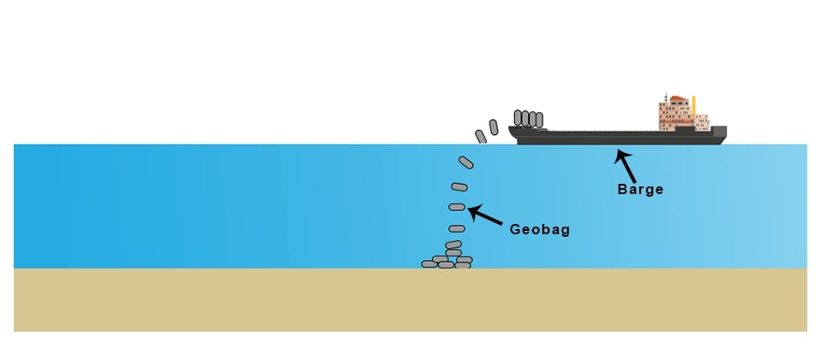
Geobag Deployment for Riverbank Erosion Control:
The strategic placement of geobags, commonly referred to as geobag dumping, is employed as an effective measure to protect riverbanks from erosion. These geobags, typically filled with sand or other suitable materials, act as flexible, permeable barriers that absorb and reduce the impact of flowing water, thereby stabilizing the riverbank and preventing soil loss. This method offers a cost-effective and environmentally friendly solution for controlling erosion in vulnerable riverine areas.

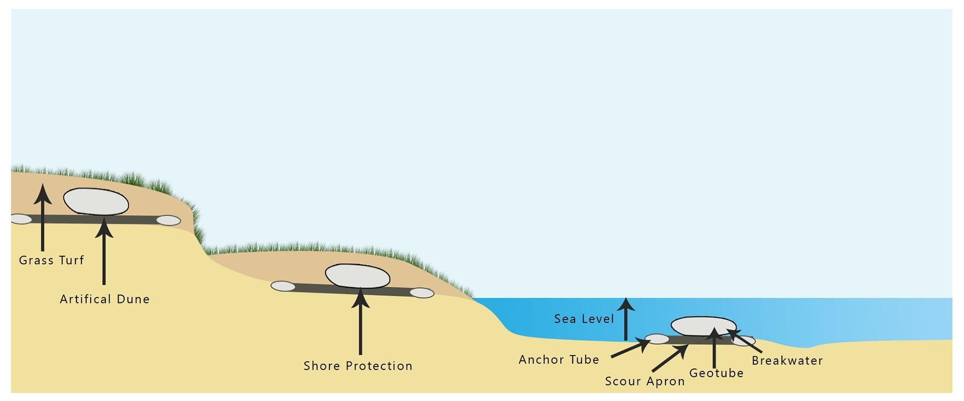

Shoreline Management:
Geotubes are utilized in shoreline management as an effective measure to protect coastal and riverine areas against erosion and flooding. These large, tubular geosynthetic containers are filled with sediment or sand, creating robust barriers that absorb wave energy and reduce the impact of water forces. By stabilizing shorelines and controlling sediment movement, geotubes help maintain the integrity of vulnerable coastal zones and mitigate flood risks.

Quality Assurance Section:
At B.J. Geo-textile Ltd., quality assurance is a fundamental component of our manufacturing and operational processes. We are committed to delivering products that consistently meet or exceed industry standards and client expectations. Our comprehensive quality assurance framework ensures that every stage of production—from raw material selection to final product testing—is carefully monitored and controlled.
Our quality management system adheres to internationally recognized standards, such as ISO 9001, and incorporates rigorous inspection protocols, material traceability, and continuous improvement practices. Advanced laboratory testing is conducted on all geotextile products to assess critical parameters including tensile strength, permeability, puncture resistance, elongation, and UV stability.
ISO Certified
RM GeoTex Ltd. is proudly ISO 9001 certified, reflecting its commitment to maintaining the highest standards in quality management. The company ensures complete traceability across its entire manufacturing process, from raw material sourcing to final product delivery.
With a team of over 30+ qualified engineers, RM GeoTex Ltd. integrates technical expertise at every stage of operation—spanning production, quality control, product design, marketing, and on-site implementation. This hands-on involvement ensures that each product meets stringent performance and reliability standards, tailored to the specific needs of its clients.

Geotextile Testing Laboratory
RM Geotex Ltd. maintains a fully equipped, in-house geotextile testing laboratory to support its rigorous quality assurance processes. As part of our commitment to excellence, all products undergo comprehensive quality checks to ensure they meet both international standards and project-specific requirements.
Our state-of-the-art laboratory is outfitted with advanced testing equipment capable of evaluating a wide range of mechanical and physical properties of geotextiles, including tensile strength, elongation, puncture resistance, permeability, and thickness. These capabilities allow us to conduct thorough performance testing under controlled conditions, ensuring that every batch meets the highest standards of durability, consistency, and functionality.
By integrating laboratory testing into every stage of production, we ensure the reliability and performance of our geotextile products in critical civil engineering and environmental applications.

Research & Development
At RM Geotex Ltd., innovation is a core pillar of our operations. We maintain a dedicated Research and Development (R&D) team focused on advancing product quality, enhancing performance, and optimizing manufacturing processes. Our R&D efforts are driven by a commitment to continuous improvement and technological advancement, enabling us to respond effectively to evolving industry demands and customer needs.
The R&D team actively explores new materials, production techniques, and application-specific solutions to ensure our geotextile products remain at the forefront of durability, efficiency, and environmental sustainability. By integrating cutting-edge technology and data-driven methodologies, we strive to improve product lifecycle, reduce production costs, and increase overall operational efficiency.
This ongoing investment in research and innovation positions RM Geotex Ltd. as a leader in geotextile development and a trusted partner for engineering and infrastructure projects worldwide.

